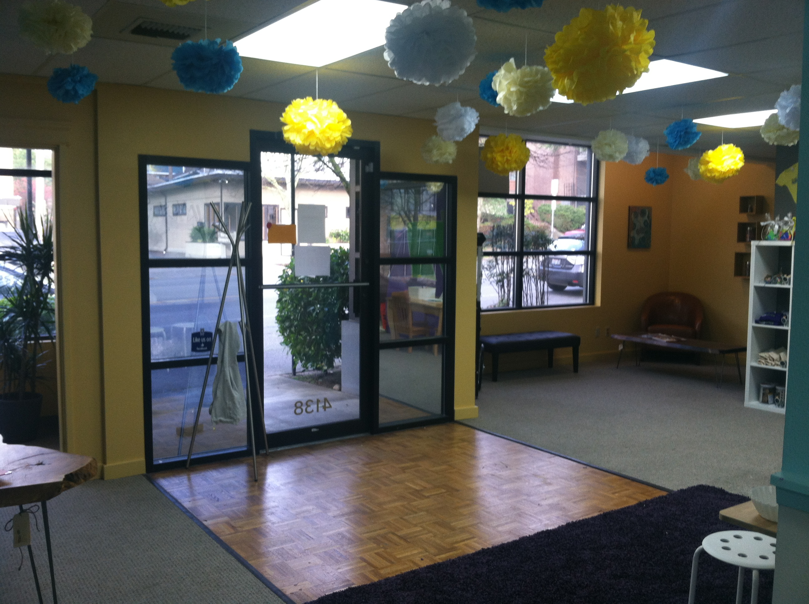  Art Nest lobby  Prices  Open studio …$10/hr. (all ages)  After school art…$25/session ( ages 5 & up drop off)  Paint & sip…$40/session ( 21 & over)  Art camp…$75/day…$250/week (5 & up)  Birthday parties…$250 open studio style, $325 deluxe (all parties include the space for 2 hours, art facilitator ,art supplies, s and art goodie bags)  Parents’ Night Out- $35.00 per artist. We get the pizza snacks, and provide an art filled evening, while you enjoy some time away.  Call for private party, space rental for events, meetings, work parties, & holiday parties.  Contact Us  Phone: 206-466-6028  Email: hello@weatseattleartnest.com  Web: www. westseattleartnest.com |  |  | About Us  The Art Nest is a freestyle open studio, for children of all ages. We offer a fun space for your children to explore their creativity. We specialize in open studio, parties of all kinds; for all ages, art camps, after school art, adult paint night, and parents’ night out. as well as specialty crafting classes. Check our website often for offerings!  The studio offers a wide variety of art projects, and spaces to create. We keep it fresh with new ideas all the time.  The Recycle Room- Loaded with a variety of recyclable art supplies. Let your artists’ imagination run wild! Toilet paper tubes make awesome castles!  The Beading and Fabric Room- Beading supplies for all kinds of jewelry making, and a variety of fabrics and beginning sewing projects available.  The Paint Splatter Room- Paint the walls!   west Seattle Art Nest 4138 California Ave SW Seattle, WA 98116 |  |  | 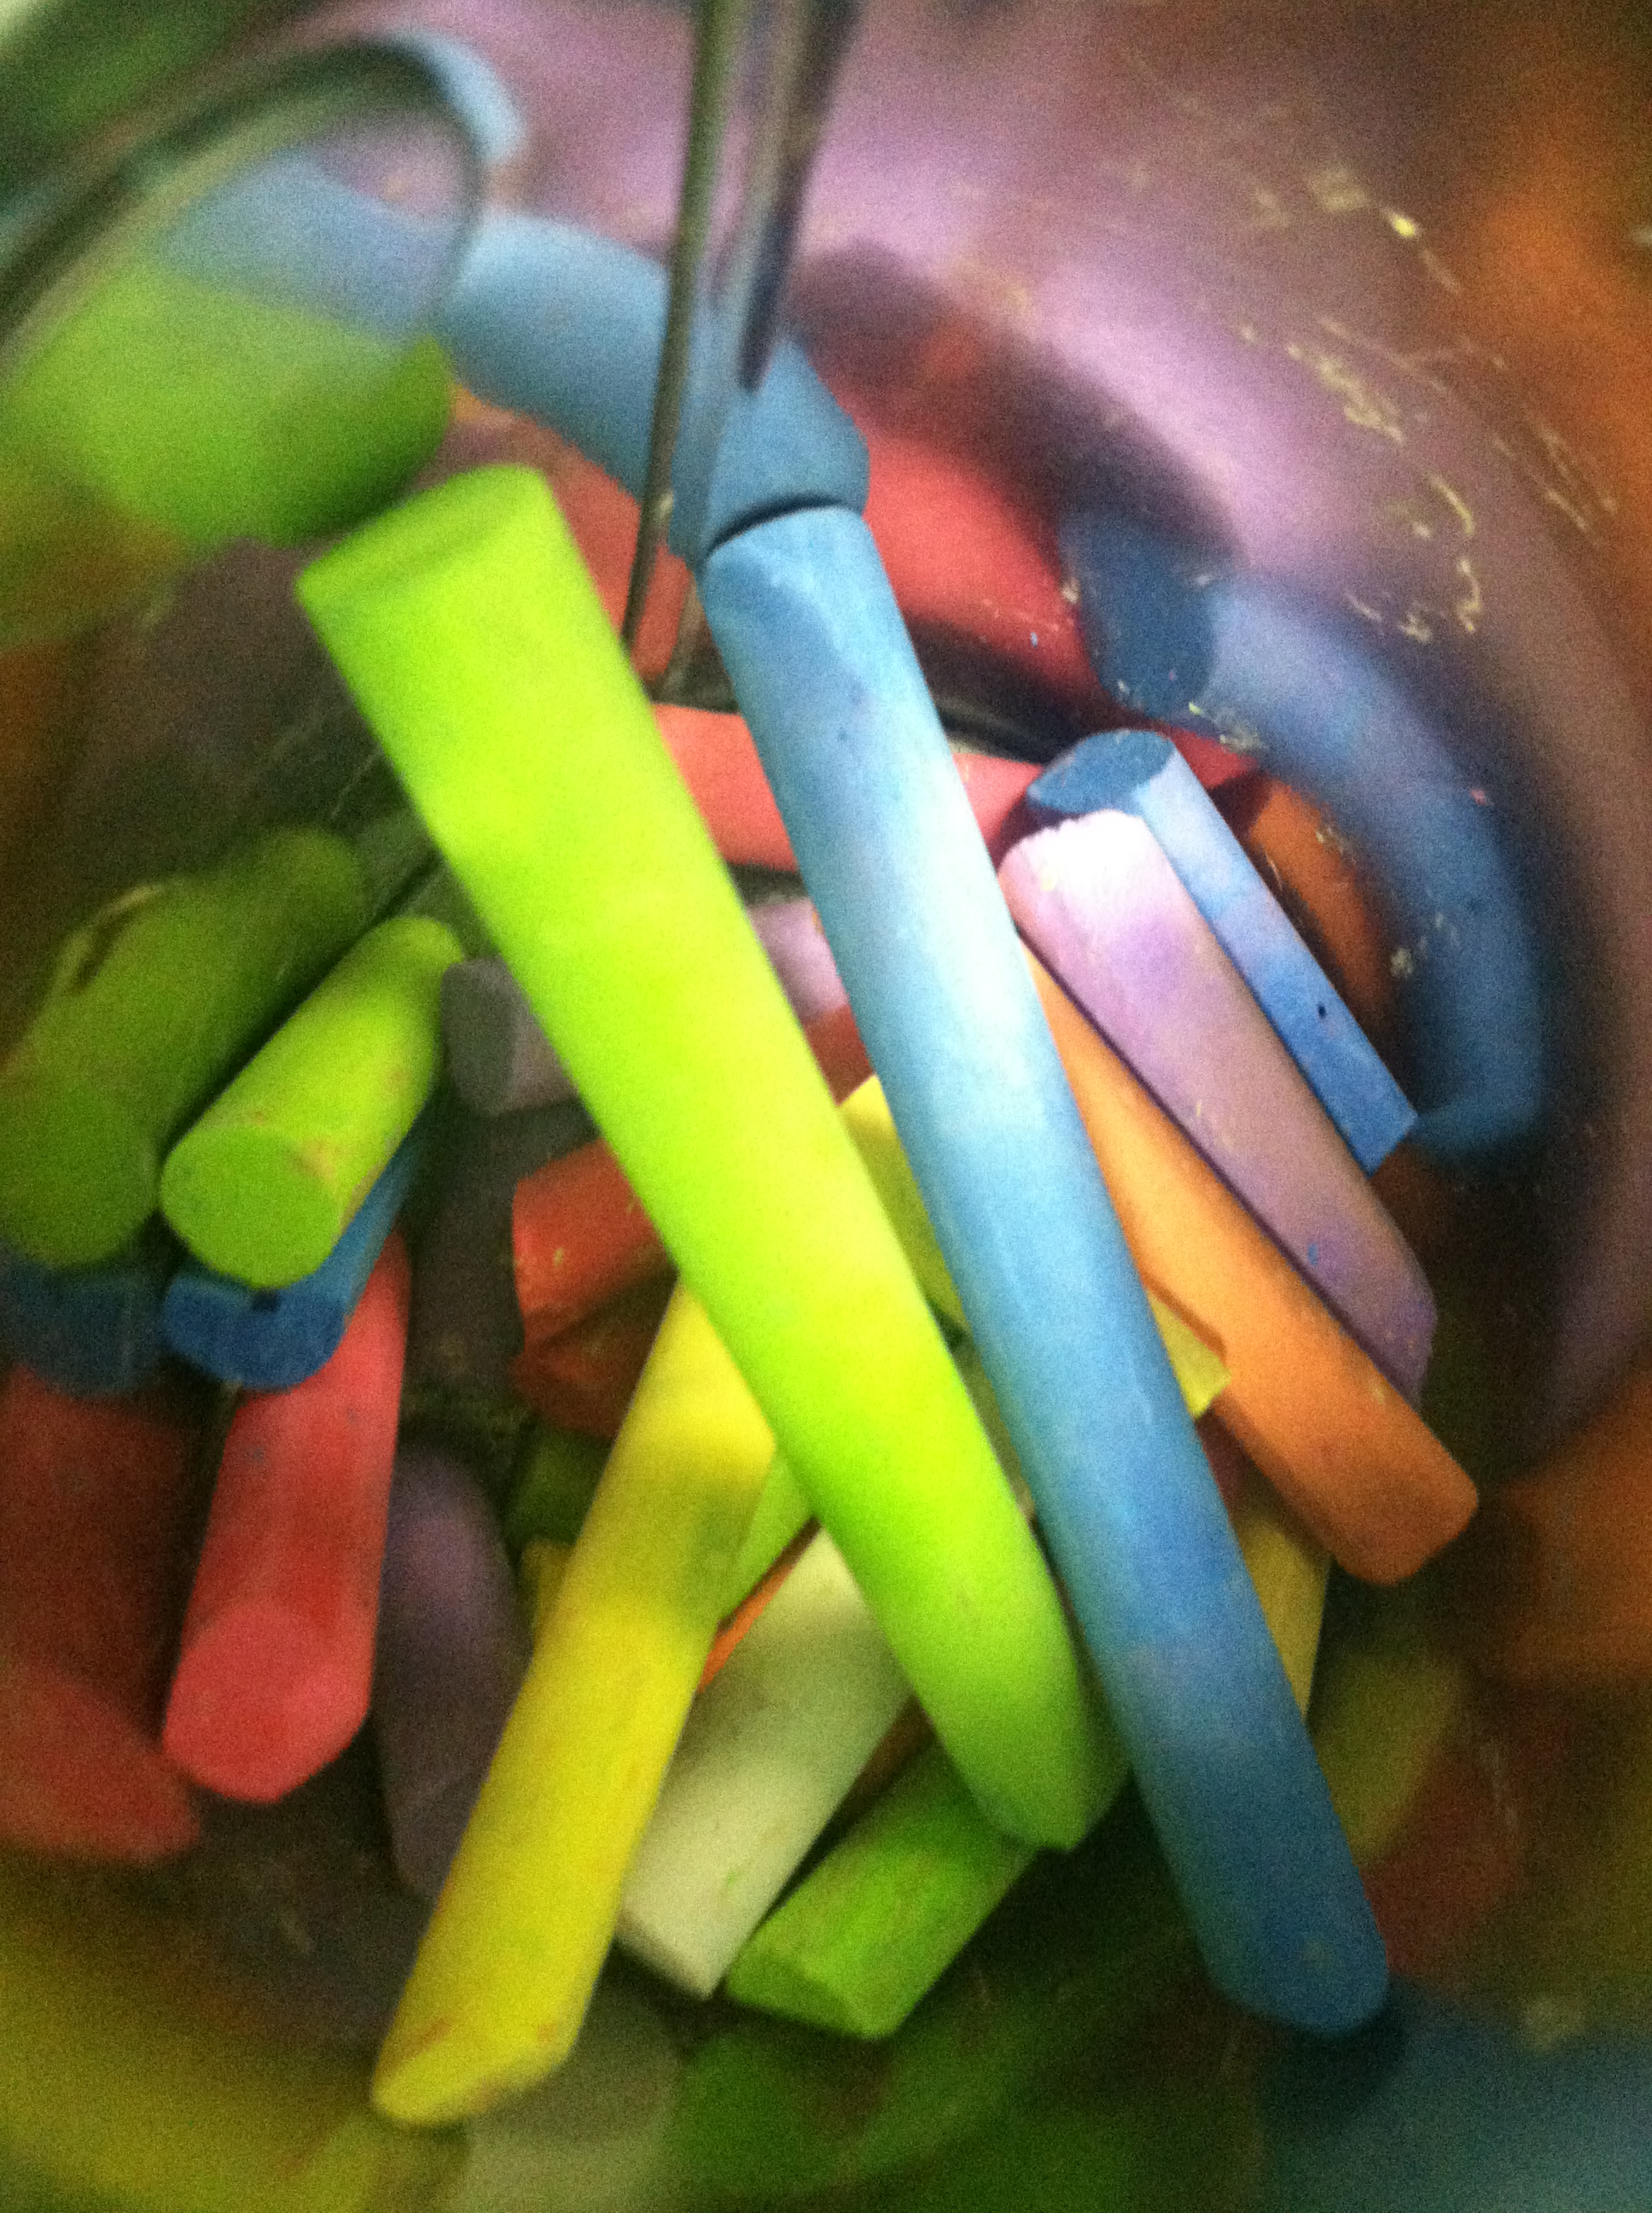  west Seattle Art Nest  - Where art has no limits or expectations, just imagination.

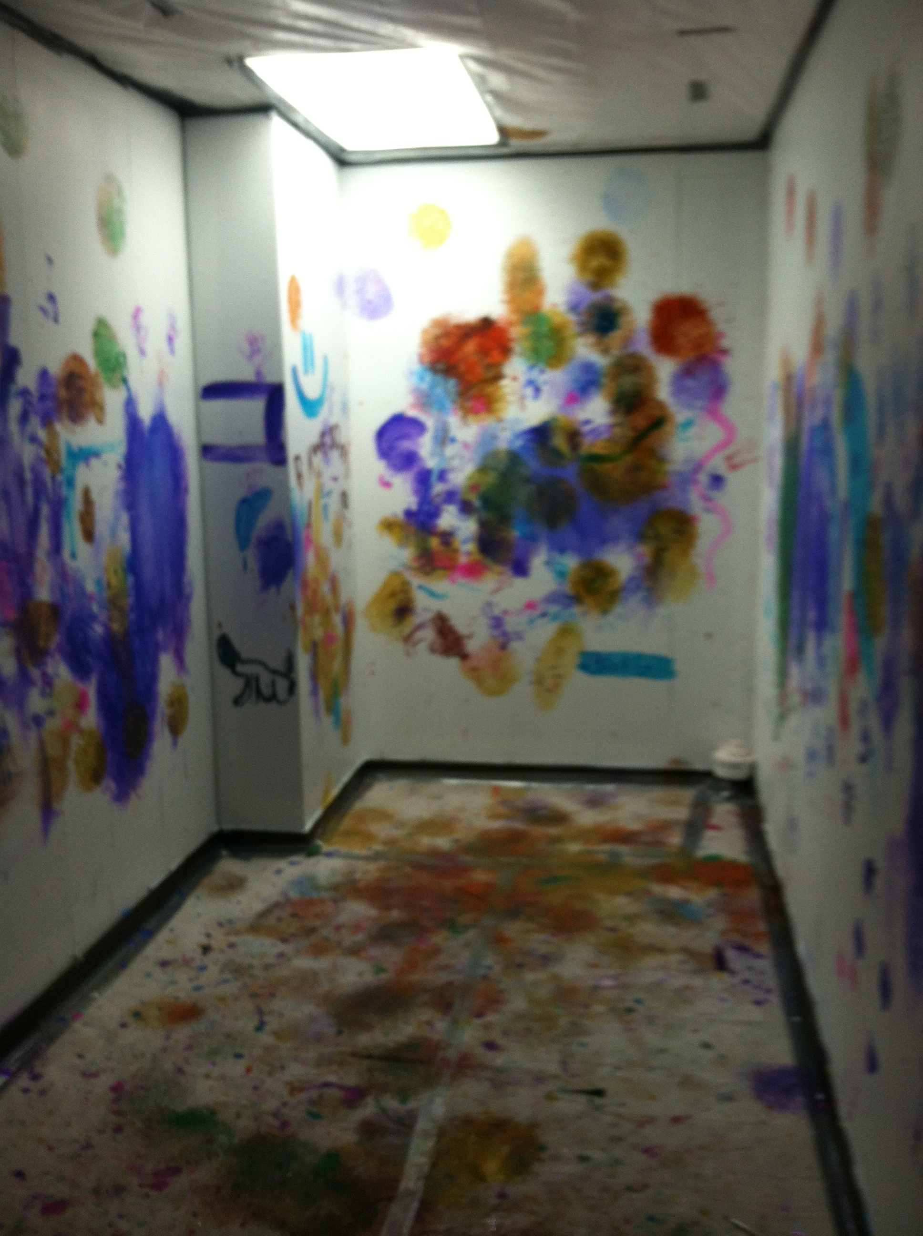  Action Painting room!  This one of a kind room is for the action painter in everyone. You are encouraged to throw paint balls at the walls, and paint whatever you feel like in the room.  Canvases are available for taking home your very own action painting. $5/canvas  The paint is non-toxic and washable. While we do have smocks for use in the studio, it is always a great idea to dress for a mess  Oh it’s not just for the kids….Adult action paint nights are available upon request. |  |  | Birthday Parties  Let’s Party…we specialize in free-style, themed, and guided art parties for all ages. We have a recycle room, paint room, fabric and beading room, as well as the main art stations, in addition to a playroom for the roaming artist all for you to enjoy.  After School Art- an enriching experience for those budding artists.  Art Camp  Art camp is designed for ages 5 & up. Camp is from 9am – 2pm. While each week is “themed” we explore a variety of art, science, and music, with special guests sharing their talents with your artists. Please bring a water bottle, a sack lunch, and dress for an artful day. |  |  | 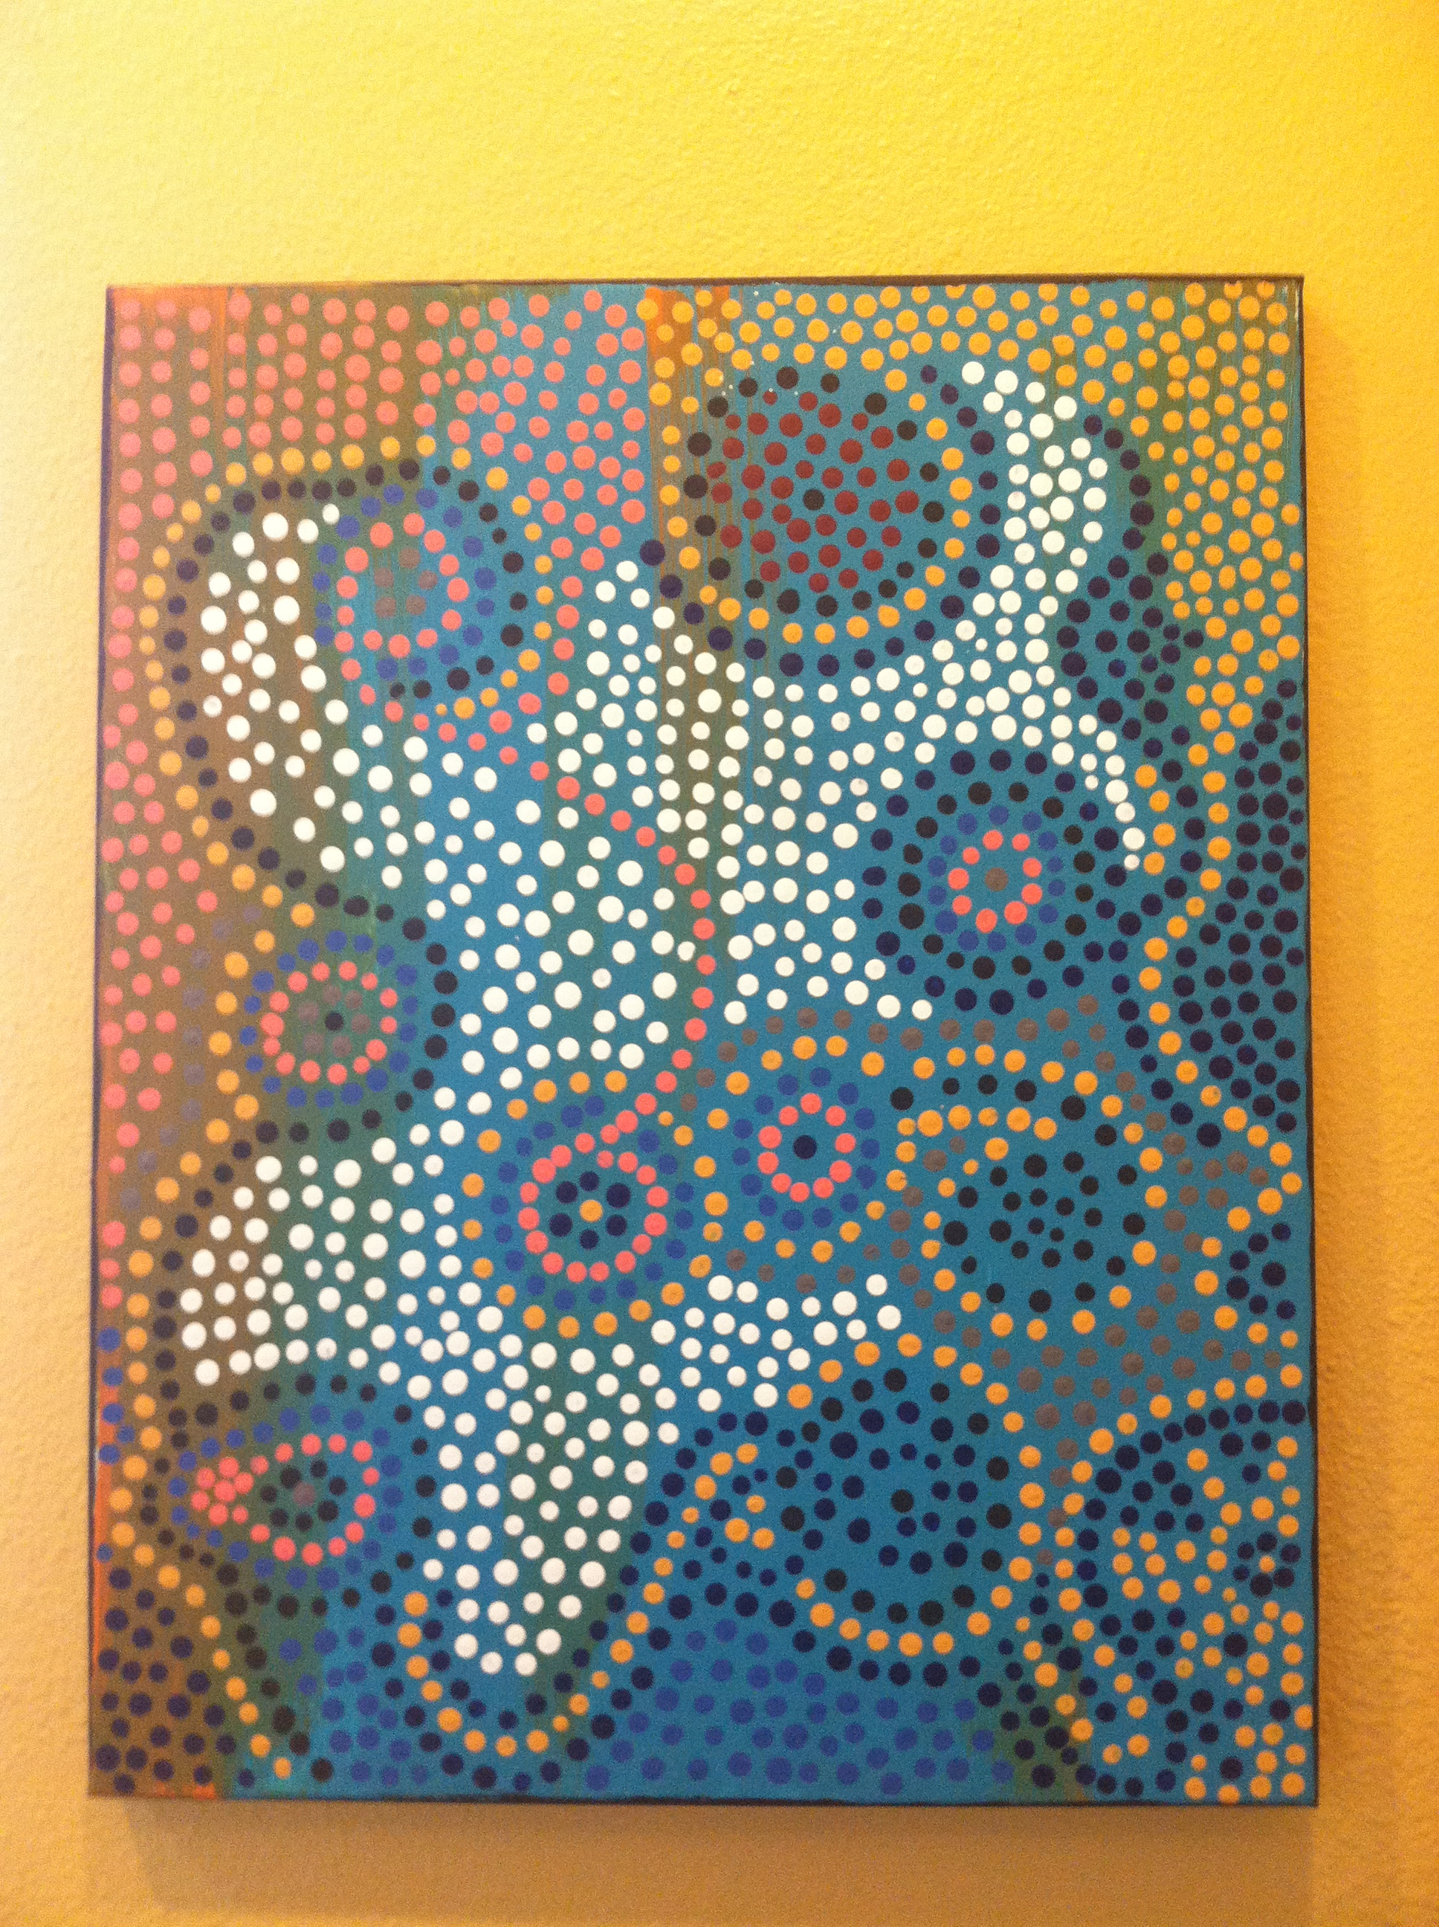  The places I’ve been…so far. Story telling through a traditional Aboriginal painting style.  Paint Night with Ms. Christi  Join us for Adult Paint night with Ms. Christi! Create your masterpiece, while sipping wine, and noshing on light snacks. Christi will guide you through each step, giving you the tools to feel comfortable with your masterpiece. Sign up available online, via email, phone, or Facebook.

