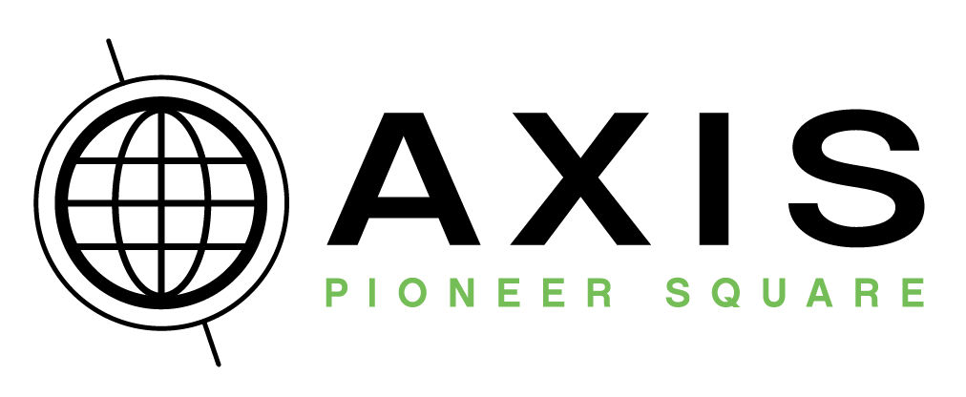
by

AXIS is housed in the historic 122-year-old Globe Building in the heart of Pioneer Square. This 6000 sqft space is an axis point for history, art, culture, photography, and events. Brick walls & 18ft archways make this multi-use space the perfect setting for every event imaginable. With a capacity of 400 (250 seated), it is among the largest non-traditional venues in Seattle and antidote to stale hotel ballrooms everywhere.
Venue Rental Rates: January - April and November

Monday – Thursday  8 hours | Friday & Sunday  8 hours | Saturday (8 am–4 pm)  $2800 | Saturday 10 hours $4800
$2800 | $3400 | Saturday (5 pm–1 am)  $4000 | Saturday 12 hours $5200

Venue Rental Rates: May – October and December

Monday – Thursday  8 hours | Friday & Sunday  8 hours | Saturday (8 am–4 pm)  $3200 | Saturday 10 hours $5600
$2800 | $3800 | Saturday (5 pm–1 am)  $4800 | Saturday 12 hours $6000
Your Rental Includes

- 8 continuous hours of venue time including set-up & tear-down time (Longer rentals available or you may add extra hours)
- Optional 1 hour wedding rehearsal
- Mezzanine Lounge area & Furniture
- Onsite Venue Representative & Security
- Use of our in-house AV: speakers, projectors, HD TV screens, lighting, etc.
- Additional tables/chairs are available to rent. Our in-house rentals allow you to avoid hefty delivery & pickup charges
- Use of Gallery AXIS & optional Nord Alley
- Catering Kitchen & Bar

- AXIS Table/Chair discounts extended with a hired planner/coordinator, and/or on 10 & 12 hour rental
- Extra Hours: $400/hr pre-paid or $500/hr day of event (not available on Saturday – Day events)
- City of Seattle $230 permit fee for Nord Alley use
- WA sales tax applies to all rentals
- Holiday weekend Sundays: Saturday rates apply
- A non-refundable deposit of 50% to book venue
- Client may purchase and supply own alcohol
- All alcohol must be served by AXIS’s caterer’s bartending staff
- Please allow at least 2 hours for set-up prior to guest arrival and 1 hour for tear-down for your event
- Events must end by 2am & space vacant by 3am
- Rates valid for events booked through 1/31/15

We offer five caterer options which provides our clients a wide range of menu options & price points. Our preferred caterers will also provide bar service. Custom menu options & tasting appointments are available – please contact the caterers individually for more information. Please note that use of one of these caterers is REQUIRED – we are not able to allow outside caterers.
Shooby Doo Catering
Outstanding catering and top-of-the-line staff at affordable prices. Voted by King 5's Evening Magazine Best Caterer in Western Washington, they specialize in European, Asian, Latin and American Cuisines.
Contact Person: Callie
Contact info: 425.361.1725, feedme@shoobydoocatering.com
Website: www.shoobydoocatering.com

Duos Catering
Your source for local & sustainably produced food with progressive flavors & unique concepts. Their chefs take pride in knowing that they provide flavorful, hand-made, and conscious meals.
Contact Person: Alicia
Contact info: 206.452.2452, alicia@duoscatering.com
Website: www.duoscatering.com

Ravishing Radish
Food is art for Ravishing Radish, producing festive menus based on local, in-season ingredients which always take center-stage.
Contact Person: Kalila
Contact info: 206.860.7449, kalila@ravishingradish.com
Website: www.ravishingradish.com

City Catering
Named by Seattle Magazine as Seattle's Most Creative Caterer, City Catering strives to pair seasonal and fresh food with warm professional service and a sleek urban style.
Contact Person: Shana
Contact info: 206.721.0334, shana@citycateringcompany.com
Website: www.citycateringcompany.com

Gourmondo Catering Co.
Using only the freshest ingredients sourced from local vendors and small farms, our menus are a reflection of where we began over 15 years ago, as a small café in Seattle’s Pike Place Market. Personalized service, attention to detail and our commitment to innovation ensures a remarkable event.
Contact person: Lindsey
Contact info: 206.587.0190, Lindsey@gourmondocatering.com
Website: www.gourmondocatering.com

Bar Service (Alcohol Provided – Cash Bar Option)

All American Bar Catering
Fully insured liquid catering supplying alcohol and servers for cash bars and hosted bars.
Contact Person: Greg Garrison
Contact info: 206.545.7771, greg@allamericancatering.com
Website: www.allamericancatering.com

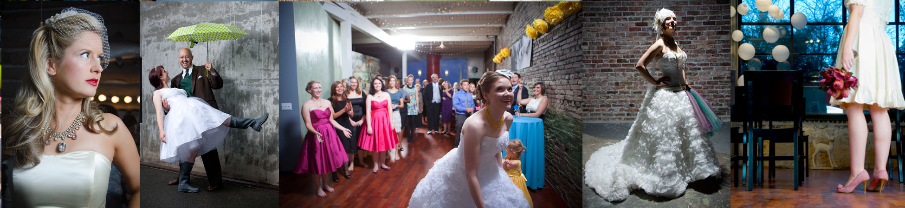

EVENT PHOTOGRAPHY

One of the advantages to hosting your event in a photo studio is that we have a talented photography team at your disposal to shoot your event with pro studio equipment and lighting. We rig hidden remote flashes into the ceilings and nooks, allowing us to photograph your event as we would a fashion shoot. The result is striking, as we are able to capture event images far beyond the ordinary (we do not allow outside photographers to set up in this manner). Our photographers are carefully selected for their creativity and ability to collaborate with studio owner Kevin Law and ensure a unique style that captures the memories of your day.

If you shop around, we think you’ll agree that some event photographer fees have become excessive. Once you have hired a photographer, we don’t believe you should have to pay exorbitant fees to order prints and albums after the fact. So we give you all of the images from your day on disc with full rights to make prints and albums for whoever you want. No strings attached.

As a unique option for your event, we can also set up our Photo-Booth so your guests can visit during the event for unlimited candid photos shot in the style of a professional fashion shoot – like a traditional “photo booth” but way more fun! This is always a big hit as well as a fun way to get memorable shots of your guests looking their best - and photo booth images can be streamed live, making for great entertainment.

Rates
Event photography base package  Includes 2 photographers and up to 8 hours continuous coverage of all aspects of your event, including formal shots with family and bridal party. Photographers can travel in the Seattle area without an additional fee. All images are individually edited and provided on disc with full usage rights. | $2500
Additional Options:

Photo Booth: “Fashion Shoot” with a ULS photographer, lighting, backdrop, props, up to 4 continuous hours of operation, and includes all images edited and provided on disc with full usage rights. Images are also hosted online for easy access to guests for downloads & prints. | + $1000  ($1500 without base photography)
Engagement photos in studio and/or on location | $500

A deposit (non-refundable) of $500 is requested to book photo packages and/or photo booth
*4 to 6 week standard processing time. Rush processing available for additional fee.

