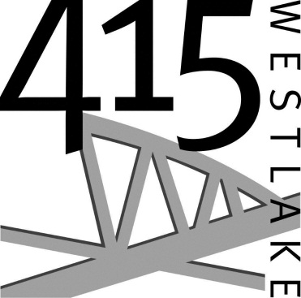**415 Westlake**

**Technical Specifications**

**Venue**

* Capacity for up to 250 in banquet style seating, 300 in theater style seating
* Accessible restrooms (3 stalls, 2 sinks in women’s, 1 stall, 1 urinal, 1 sink in men’s)
* Radiant floor heating
* High speed internet (1000mbps out, 100 Mbps in)
* Wireless internet throughout
* ̴6,4002 ft. ( ̴36002 ft. in main room, ̴18002 ft. in café space)

**Seating/Furniture**

* White banquet chairs (215)
* 60” round tables (25)
* 4’ x 2’ banquet tables (2)
* 6’ x 30” banquet tables (3)
* Café furniture and soft seating
* Portable staging (3 sections, 4’ x 8’ each, combinable up to 12’ x 8’, 16” high)

**Audio/Visual**

* Eiki 7000 lumen HD projector
* 12’ x 9’ 16:9 aspect ratio screen
* Blueray player, Mac and PC projection compatibility
* 55” Toshiba flat panel TV, Bose speakers in café space
* Renkus-Heinz loudspeakers in main room
* Behringer 32 channel digital sound board
* Shure UR4D wireless system (2 hand-held Beta 58s, 2 lapels), Sennheiser e835 mics
* Elation lighting (Design Spot Pro 250 robotic light, 6 ELED Tri 64B Par Cans, 4 Color LEDs, Show Designer 2 board)
* We Present WiFi presentation system

**Kitchen**

* 4 convection ovens
* Double warming box
* 5 burner gas range with wok burner
* FETCO 2 gallon coffee brewer
* 70lb ice machine
* 3 prep tables
* Refrigerator and freezer space